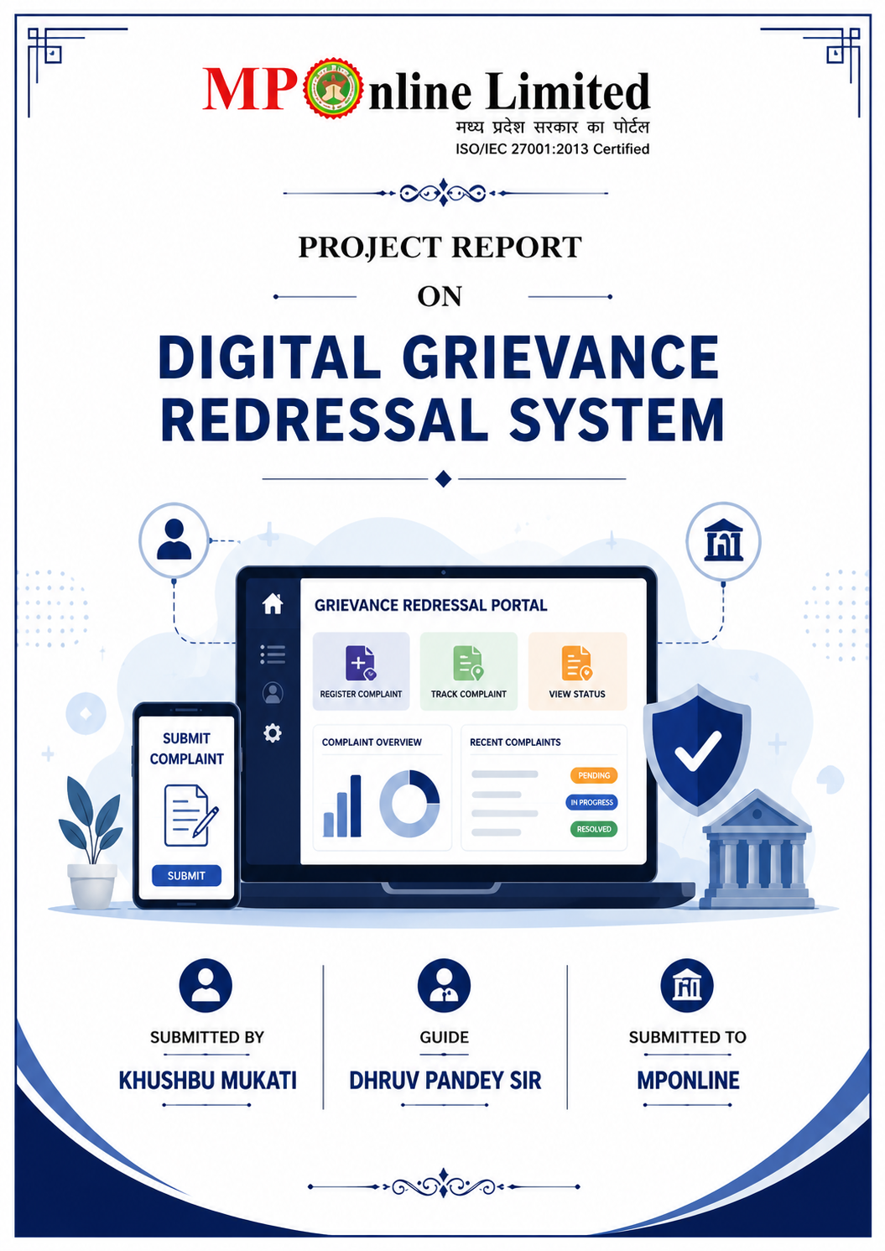

Content
- Abstract
1. Introduction:-
  - Problem Domain
  - Solution Domain
  - Purpose & Scope
  - Definition
  - Keyword
  - Technology
2. Requirement gathering analysis:-
  - SRS
  - Feasibility Analysis
  - Technical Feasibility
  - Economical Feasibility
  - Hardware Requirement
2.6 Software Requirement
3.Design
  - Use Case Diagram
  - E-R diagram
  - Data Flow diagram
  - Class diagram
4.Testing
5.Implementation
6.Snapshot
7.Conclusion
8.Limitation
9.Future Enhancement
10.Reference

- Abstract
The Digital Grievance Redressal System is a web-based application developed to simplify and digitize the complaint management process between citizens and government authorities. In traditional systems, citizens often face difficulties in registering complaints, tracking complaint status, and receiving timely updates regarding grievance resolution. This project provides a centralized online platform where citizens can submit complaints, upload supporting evidence, and monitor complaint progress in real time.
The system consists of two primary modules: Citizen Module and Admin Module. Citizens can register, log in, submit grievances, upload documents/images as proof, and track complaint status. Administrators can view all complaints, update complaint statuses, analyse complaint statistics, and manage registered users. The application enhances transparency, accountability, and efficiency in grievance handling.
The project is developed using React.js for the frontend, Fast API for the backend, MySQL for database management, and JWT Authentication for secure access control. The system ensures a user-friendly interface, secure data management, and real-time complaint tracking capabilities.
Key Features
- Online complaint registration.
- Complaint status tracking.
- Evidence/document upload facility.
- Admin dashboard with analytics.
- Secure authentication using JWT.
- User and complaint management system.

- Introduction
The Digital Grievance Redressal System is designed to bridge the communication gap between citizens and authorities by providing an online complaint management platform. Citizens can easily submit grievances without visiting government offices physically. The system maintains transparency by allowing users to monitor the progress of their complaints and receive updates regarding resolution status.
The application digitizes the complete grievance lifecycle, including complaint registration, verification, processing, status updates, and resolution. It eliminates paperwork, reduces administrative workload, and improves the efficiency of complaint handling processes.
Objectives
- Provide a digital platform for grievance registration.
- Improve transparency and accountability.
- Reduce manual paperwork.
- Enable real-time complaint tracking.
- Generate analytical reports for administrators.

1.1Problem Domain
In traditional grievance systems, complaint handling is mostly manual and paper-based. Citizens are often required to visit offices repeatedly to submit complaints or check complaint status. This results in delays, inefficiency, lack of transparency, and poor record management.
Problems Identified
- Manual complaint registration process.
- Lack of complaint tracking mechanism.
- Delayed grievance resolution.
- Poor data management.
- Absence of centralized complaint records.

1.2Solution Domain
The proposed Digital Grievance Redressal System provides an online platform where complaints can be registered, monitored, and resolved efficiently. It automates grievance handling processes and provides a transparent communication channel between citizens and authorities.

Solution Features
- Online complaint submission.
- Secure login and authentication.
- Complaint status tracking.
- Evidence upload support.
- Administrative monitoring dashboard.

1.3Purpose & Scope
The purpose of the project is to create a centralized grievance management platform that enables efficient complaint registration and resolution. The system ensures transparency and accountability while reducing manual intervention.

Scope
- Citizen complaint registration.
- Complaint tracking.
- Admin complaint management.
- User management.
- Complaint analytics and reporting.

1.4Definition
A Grievance Redressal System is a mechanism that enables individuals to report issues, complaints, or concerns to responsible authorities and receive appropriate resolutions within a reasonable timeframe.
Definitions
- Citizen: Registered user who submits complaints.
- Admin: Authority responsible for complaint management.
- Complaint: Issue reported by a citizen.
- Ticket ID: Unique identifier assigned to each complaint.
- Status: Current stage of complaint processing.

1.5Keywords
Project Keywords
- Grievance Management
- Complaint Tracking
- Citizen Portal
- Admin Dashboard
- Ticket Management
- Fast API
- React.js
- MySQL
- JWT Authentication
- REST API

1.6Technology
The project utilizes modern web technologies to ensure scalability, security, and maintainability.
Frontend
- React.js
- Tailwind CSS
- Recharts
- Framer Motion
- Axios
Backend
- Fast API
- Python
Database
- MySQL
Security
- JWT Authentication
- Password Hashing
Development Tools
- VS Code
- Git
- GitHub
- Postman

- Requirement Gathering Analysis
Requirement gathering is the process of identifying system functionalities and user expectations. The requirements for this project were collected based on the needs of citizens and administrators involved in grievance handling.
Functional Requirements
- User Registration & Login
- Complaint Submission
- File Upload
- Complaint Tracking
- Admin Complaint Management
- Dashboard Analytics
Non-Functional Requirements
- Security
- Reliability
- Performance
- Scalability
- Usability

2.1 SRS (Software Requirement Specification)
The SRS document defines the functional and non-functional requirements of the Digital Grievance Redressal System.
Functional Requirements
- Citizen registration and authentication.
- Complaint creation.
- Complaint status update.
- Complaint search and filtering.
- User management.

Non-Functional Requirements
- Secure access control.
- Fast response time.
- Database integrity.
- Responsive UI design
.
2.2 Feasibility Analysis
Feasibility analysis determines whether the project can be implemented successfully with available resources.

2.3 Technical Feasibility
The project is technically feasible because all required technologies are open-source, widely supported, and suitable for web application development.
Factors
- React.js supports dynamic frontend development.
- Fast API provides high-performance APIs.
- MySQL offers reliable data storage.
- JWT ensures secure authentication.

2.4 Economical Feasibility
The project is economically feasible because it uses open-source technologies and requires minimal infrastructure costs.
Benefits
- Reduced paperwork.
- Lower operational costs.
- Efficient resource utilization.
- Minimal software licensing expenses.
2.5 Hardware Requirements
Minimum Hardware
- Processor: Intel i3 or above
- RAM: 4 GB
- Storage: 20 GB Free Space
- Internet Connection
Recommended Hardware
- Processor: Intel i5/i7
- RAM: 8 GB+
- SSD Storage

2.6 Software Requirements
Software
- Windows 10/11
- Visual Studio Code
- Node.js
- Python 3.10+
- MySQL Server
- Git & GitHub
- Web Browser (Chrome)
- Design
System design defines the structure and workflow of the application.
Design Components
- Frontend Interface
- Backend API Layer
- Database Layer
- Authentication Module
3.1 Use Case Diagram
The Use Case Diagram represents interactions between Citizens and Admins.
Actors
- Citizen
- Admin
Citizen Activities
- Register
- Login
- Submit Complaint
- Upload Evidence
- Track Complaint
Admin Activities
- View Complaints
- Update Status
- Manage Users
- View Dashboard
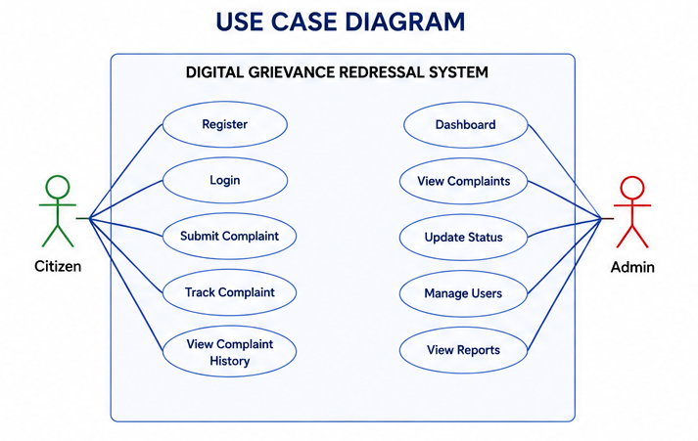
3.2 ER Diagram
The ER Diagram illustrates relationships between Users and Complaints.
Entities
- User
- Complaint
Relationship
- One User → Many Complaints

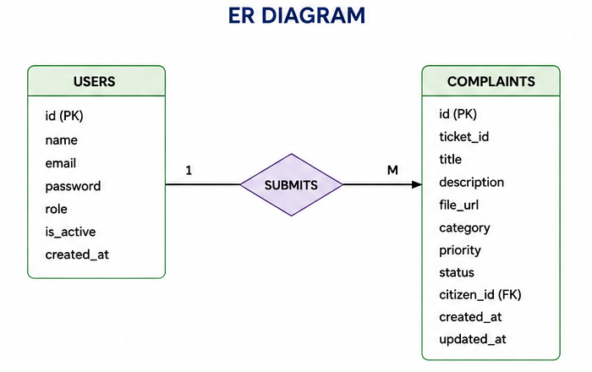

3.3 Data Flow Diagram
The DFD shows how information flows through the system.
Processes
- User Authentication
- Complaint Submission
- Complaint Processing
- Status Update

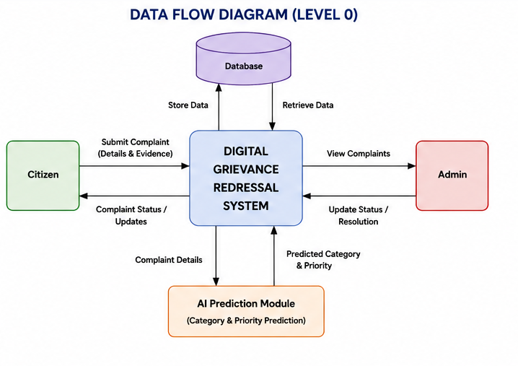

3.4 Class Diagram
The Class Diagram shows classes and their relationships.
Classes
- User
- Complaint
- Admin
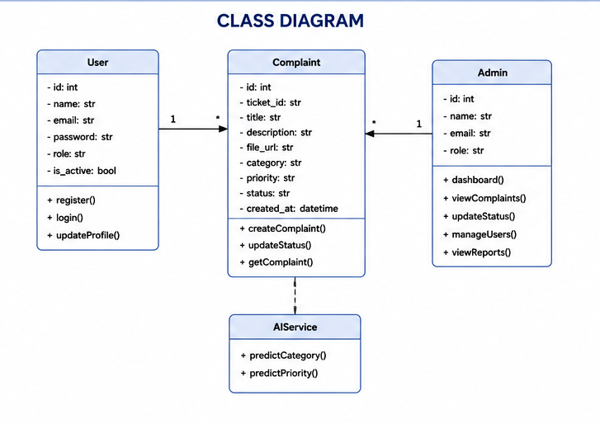

- Testing
Testing was performed to verify the functionality and reliability of the system.
Testing Types
- Unit Testing
- Integration Testing
- Functional Testing
- UI Testing

- Test Cases
Test Case | Expected Result | Status
Login | Successful Login | Pass
Registration | Account Created | Pass
Submit Complaint | Complaint Stored | Pass
Upload File | File Uploaded | Pass
Update Status | Status Updated | Pass
Bugs Encountered & Fixes
Issue | Solution
CORS Error | Configured CORS Middleware
JWT Authentication Error | Corrected Token Validation
File Upload Failure | Fixed Multipart Handling
API Route Errors | Updated Endpoint Mapping
State Update Issues | Used React State Management

- Implementation
The implementation phase involved frontend development, backend API integration, database configuration, authentication setup, and testing.

Modules Implemented
Citizen Module
- Registration
- Login
- Complaint Submission
- Complaint Tracking
Admin Module
- Dashboard
- Complaint Management
- User Management
- Analytics
Security Module
- JWT Authentication
- Password Hashing

- Snapshot
Include screenshots of:
Citizen Module

- Home page
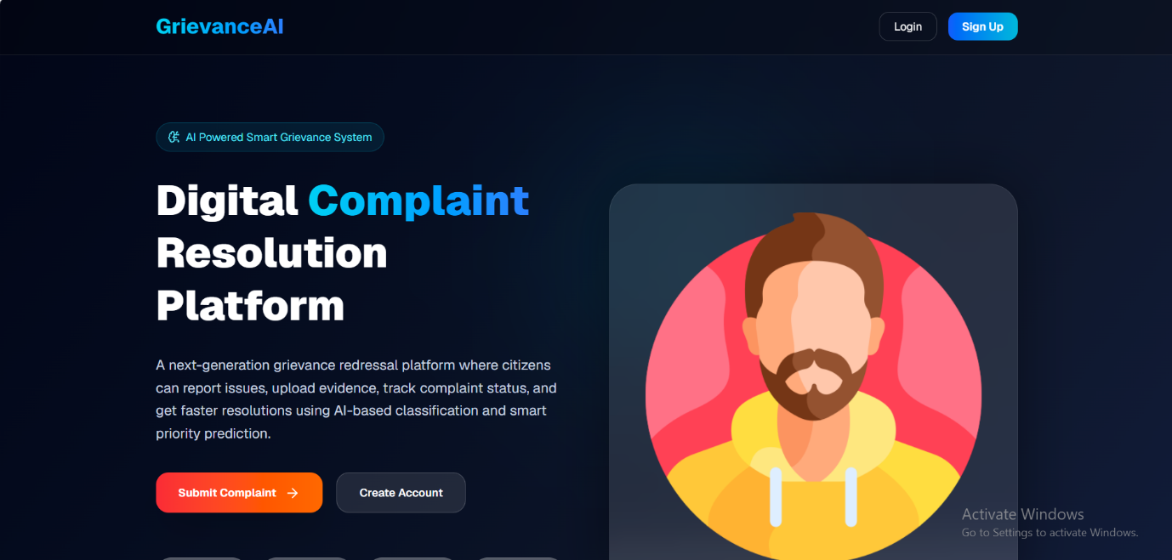
- Sing up Page

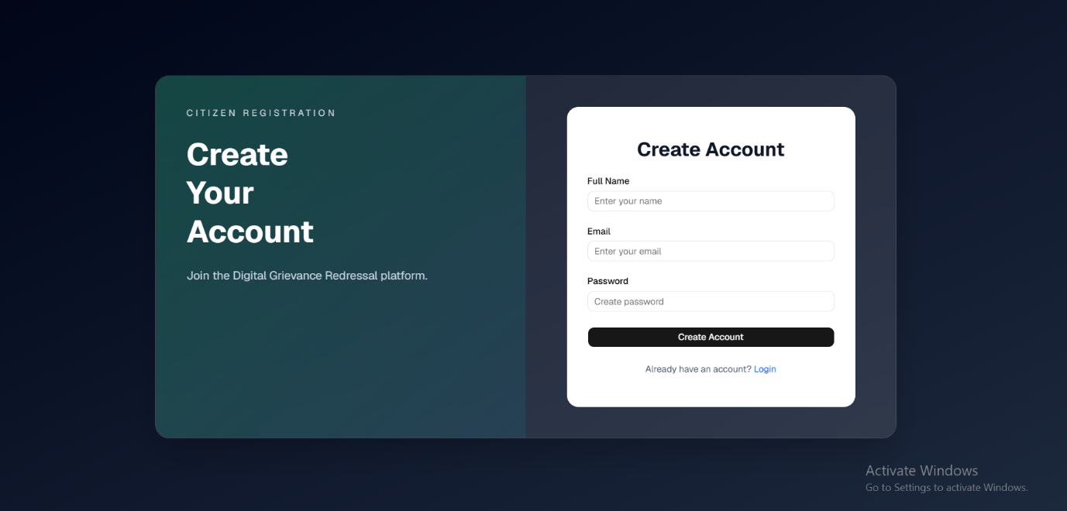

- Login Page

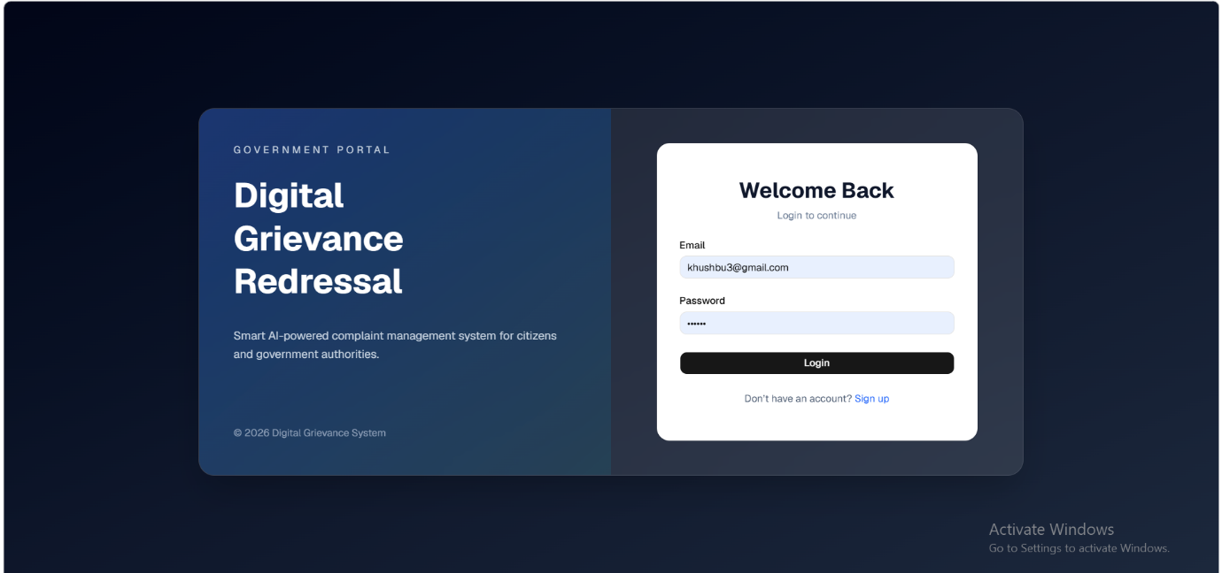
- Dashboard
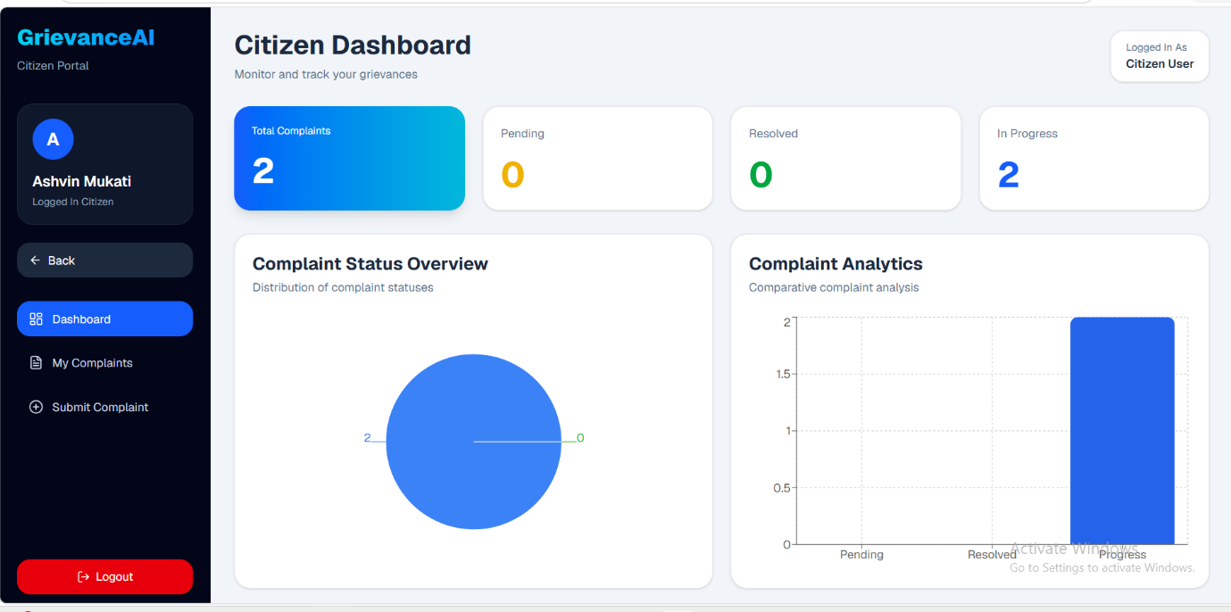

- Submit Complaint Page
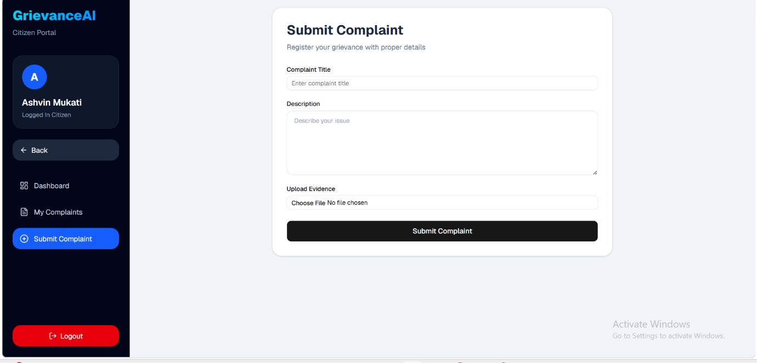

Admin Module
- Admin Dashboard
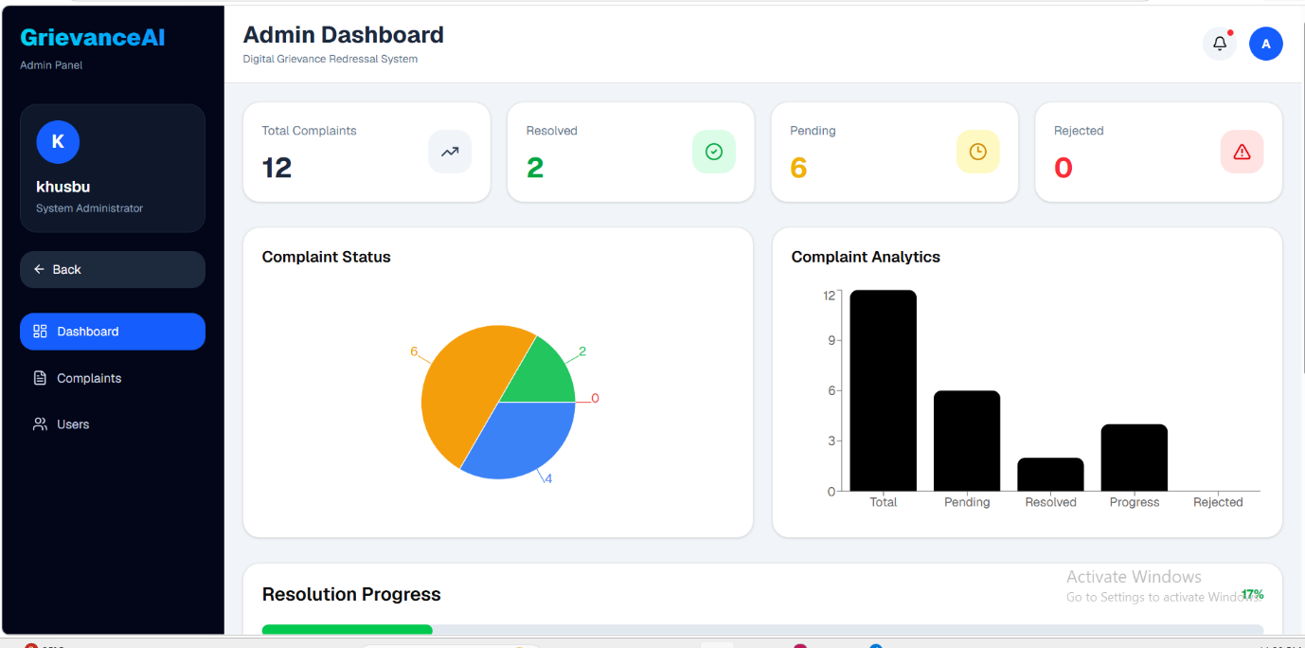

- Complaint Management
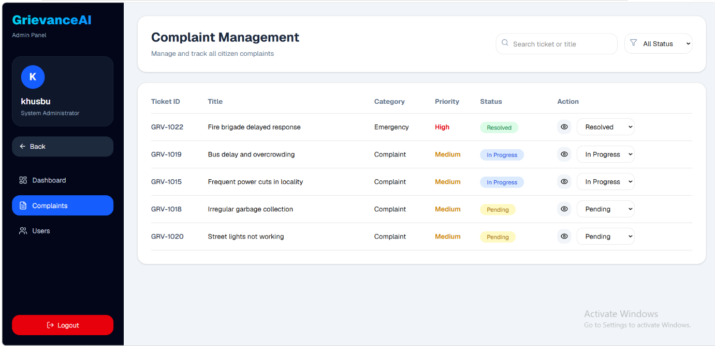

- Users Management
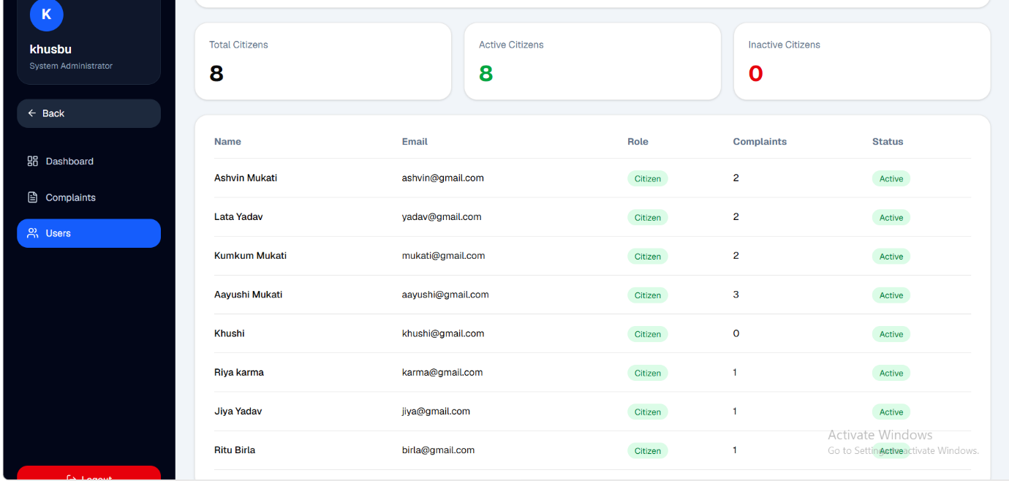

- Conclusion
The Digital Grievance Redressal System successfully provides an efficient, transparent, and secure platform for complaint management. It eliminates manual processes and allows citizens to track grievances conveniently. Administrators can manage complaints effectively through a centralized dashboard and analytics module. The project demonstrates how modern web technologies can improve public service delivery and grievance redressal mechanisms.
Outcomes
- Improved transparency.
- Reduced paperwork.
- Faster complaint processing.
- Better record management.

- Limitations
Although the system performs effectively, certain limitations exist.
Limitations
- No email notification feature.
- No SMS alerts.
- Single admin support.
- Limited reporting features.
- Requires internet connectivity.

- Future Enhancement
Several enhancements can be implemented in future versions.
Future Scope
- Email Notifications
- SMS Alerts
- Multi-Level Admin System
- AI-Based Complaint Categorization
- Mobile Application
- Real-Time Chat Support
- Advanced Analytics Dashboard
- Complaint Escalation Mechanism

- References
Documentation
- React.js Documentation – https://react.dev
- Fast API Documentation – https://fastapi.tiangolo.com
- MySQL Documentation – https://dev.mysql.com/doc
- Tailwind CSS Documentation – https://tailwindcss.com

